

**____________________________________________________________________________**

# **How would investments in businesses and education affect traffic and road safety in major American cities?**

**____________________________________________________________________________**

Muhammad Zaman

William Harkless

**Table of Contents**

1. Problem Statement 2

2. Executive Summary 4

3. Data 4

4. Analysis 6

4.1 General Analysis 6

4.2 Education 12

4.3 Business 13

5. Recommendations 20

6. References 22

## **1. Problem Statement**

Traffic and road safety remains a major concern in American society today. These concerns are more prominent in urban agglomerates where populations are higher and traffic congestion is more frequent. It is undeniable that factors such as gas prices and the cost of public transportation directly impact road congestion. However, some other indirect factors remain relatively unconsidered. Our team looked into some other non-conventional indicators or triggers of traffic. The two areas of focus are the businesses present in the city, and the education of the city’s population.

In an effort to ensure that any correlation in our data can be used to indicate causation, these two indicators were chosen based on our hypotheses of what other causes of traffic could possibly be. Our hypothesis of how businesses affect traffic is that the more businesses there are and the larger scale at which they are present the more traffic contestation there is on the roads of that city. The reasoning behind this is that businesses, in general, attract people. Whether that be because of employment or because of the commercial buying and selling that takes place in stores. In terms of education, we hypothesize that the more educated a population is, the lower the traffic congestion would be on the roads. The reason is that more educated individuals tend to do less manual labor, and a significant portion of the population is given the opportunity of working from home. Fewer people traveling to and from in-person offices would indefinitely reduce traffic. Thus, for our paper we posed the following question:

**Topic Question: How would investments in businesses and education affect traffic and road safety in major American cities?**

To answer this question, we considered data from 3 major American cities. New York, NY, Austin, TX, and Washington, DC. We analyzed publicly available data on 311 calls, building permits, business licenses, and population education level statistics. We aim to provide municipal governments with recommendations on how to lower traffic congestion by altering indirect factors.

## **2. Executive Summary**

The following conclusions were made after analyzing the data:

1. Links to educational achievement of population:

· Completing a post-secondary degree at any college for adults who are above 25 decreases traffic congestion and increases road safety

· The more students that pursue majors that are related to work from home jobs lowers the traffic congestion in the city

2. Links to businesses:

· Having more businesses in any given area will increase the amount of traffic in that area.

## **3. Data**

To come up with a strong answer to our question we analyzed different datasets including the ones that were provided and some external ones as well. The following are the data that we had used in this report:

· 311 Calls datasets

o Provides information about 311 (non-emergency) calls, such as reason for call, time, location, etc.

o Data is for New York, NY, Austin, TX, and Washington, DC

o Provided by datathon organizers

· Building Permits datasets

o Provides information about permits given for construction, date issued, location, etc.

o Data is for New York, NY, Austin, TX, and Washington, DC

o Provided by datathon organizers

· Operational Buildings datasets

o Provides information about operational buildings in major cities, location, industry, etc.

o Used the provided data for New York, NY, Austin, TX, and Washington, DC

o Provided by datathon organizers

· College Majors statistics

o Provides information about the college majors completed in each city, the date issued, etc.

o Data is for New York, NY, Austin, TX, and Washington, DC

o Data is from an external source, reference number: [1]

· Educational Achievement statistics

o Provides statistics about the percentage of the population that has completed college, high school, etc.

o Data is for New York, NY, Austin, TX, and Washington, DC

o Data is from an external source, reference number: [2]

· Congestion Index statistic

o Provides an index calculated by the United States Department of Transportation to determine the traffic congestion in cities

o Data is for New York, NY, Austin, TX, and Washington, DC

o Data is from an external source, reference number: [3]

## **4. Analysis**

### **4.1 General Analysis**

In this report, we analyze the correlation between our indicators or causes and traffic congestion. As well as general trends that may affect our results or aid in our recommendations. Note that for our recommendation we are assuming that correlation leads to causation, as we had highlighted potential sources of causation in our hypothesis.

The purpose of the 311 phone line is for the population to get access to non-emergency city services. It is worth noting that although most traffic related issues are not an emergency, there are some, such as serious car accidents, that would be considered an emergency and instead 911 would be called. Thus, our 311 dataset does not include traffic issues that are an emergency. However, the 311 dataset includes vital information about the direct causes of traffic. Acknowledging this is essential as the direct instigators or effects of traffic are a great indication for how much traffic and road incidences there are and allows for a contrast between the cities.

**Graph 1.1**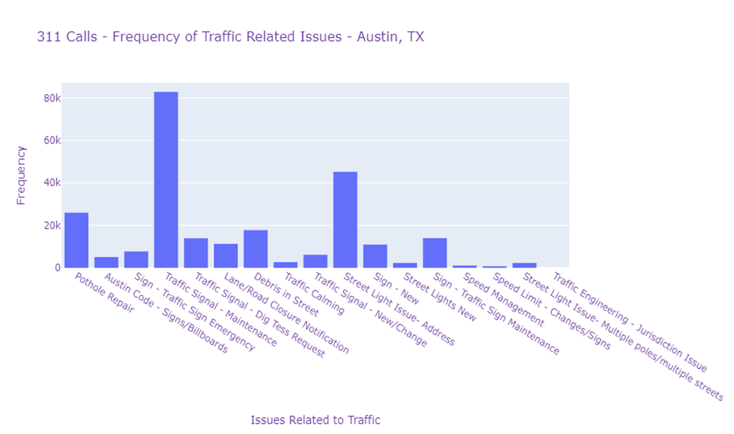

In Austin, the biggest traffic related issue is signal maintenance. This indicates that the best way to deal with traffic related issues is to ensure that street signals are properly functioning.

**Graph 1.2**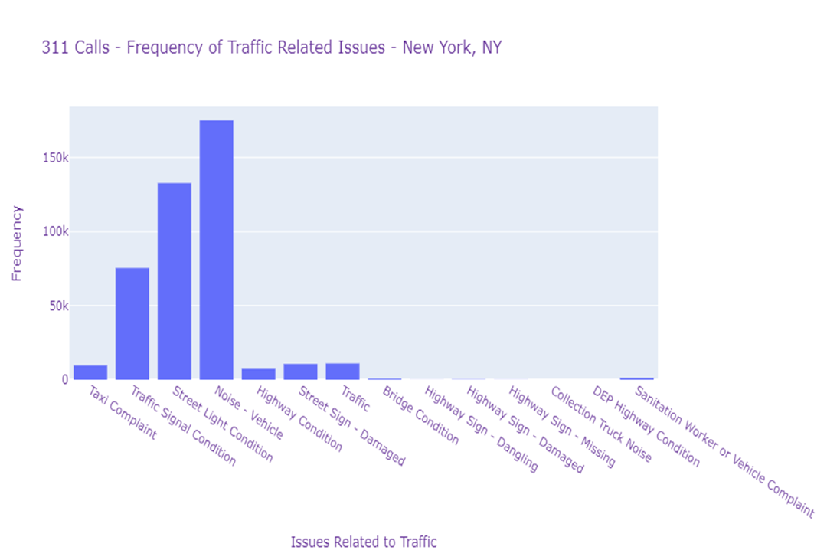

In New York, the biggest traffic related issue is vehicle noise. A huge initiator for vehicle noise is congestion in traffic. The second most predominant issue is the traffic signal condition. This again indicates that it is essential to ensure that street signals are properly functioning.

**Graph 1.3**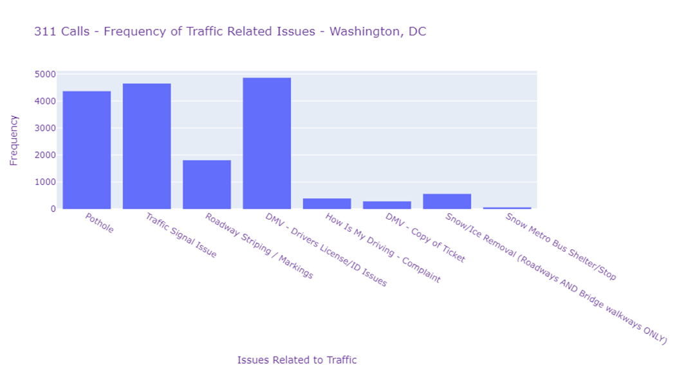

In Washington, the biggest traffic related issue is divers’ licenses. This indicates that the city is doing fairly well in its transportation sector as the issues with divers’ licensees are beyond the government’s control. However, the second most predominant issue is the traffic signal issue. This again indicates that it is essential to ensure that street signals are properly functioning.

Besides traffic, 311 calls focus on a different variety of issues. Graph 1.4 compares the frequency of 311 calls across the cities, and within the cities the frequency of calls related to traffic in contrast to other issues. This will allow us to create a contrast between the cities and determine where traffic issues are more prevalent in contrast to other non-emergency issues.

**Graph 1.4**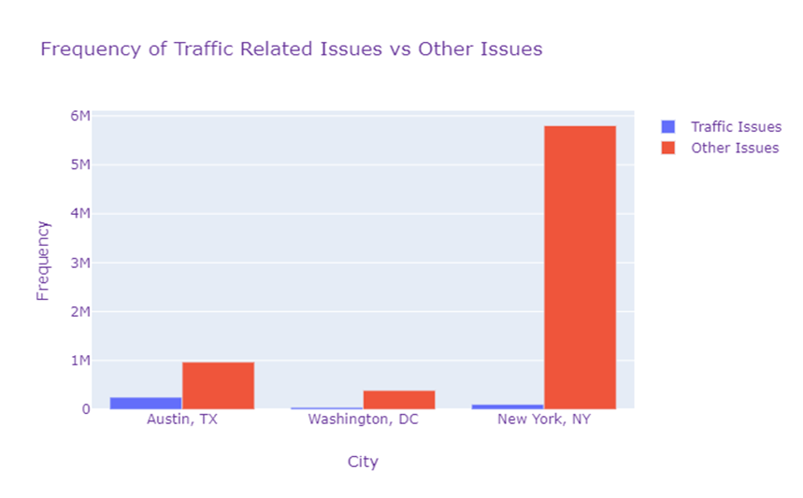

From our data here is a table of the types of 311 calls by percentage:

**Table 1.1**

| **City** | **Percentage Traffic Related (%)** |
| --- | --- |
| Austin, TX | 20.4783 |
| Washington, DC | 9.8401 |
| New York, NY | 1.6136 |

In Austin, traffic is a greater concern, in contrast to other urban issues, when compared with New York or Washington. This has two possible reasons, one being that Austin’s traffic is worse in terms of congestion and road safety in contrast to the other cities, or the other cities have more prevalent issues that monopolize the frequency of 311 calls. However, the United States Department of Transportation has calculated a Roadway Congestion Index (RCI), which is a measure of vehicle travel density on major roadways in an urban area. This is an average congestion, on the freeways and principal arterial street systems during peak periods. The higher the RCI the more roadway congestion there is, and an RCI exceeding 1.0 indicates an undesirable congestion level. Table 1.2 displays the RCI by city in 2011.

**Table 1.2 [3]**

| **City** | **Roadway Congestion Index (RCI)** |
| --- | --- |
| Austin, TX | 1.18 |
| Washington, DC | 1.02 |
| New York, NY | 1.11 |

The issue of traffic congestion and road safety is most prevalent in Austin, where both the percentage of 311 calls and RCI index indicate so. The next most relevant city is New York. Despite New York having a smaller percentage of 311 calls being traffic related, it still has more traffic in contrast to Washington. Precedence has been given to the RCI index in this comparison. The reason why other issues might monopolize 311 calls for New York is because it is far larger than the other cities. It has more urban issues that take precedence over traffic, examples being water, flooding, and sanitation. Thus, people tend to call more for those issues than they do for traffic related ones. This data overall supports our finding from the 311 calls. Thus, the order of traffic from highest to lowest in the three cities is Austin, New York, and then Washington.

### **4.2 Education**

Education levels across the three cities vary quite a bit. Table 2.1 indicates the percentage of the population of adults above 25 that have completed college.

**Table 2.1 [2]**

| **City** | **Percentage Above 25 Completed College (%)** |
| --- | --- |
| Austin, TX | 23.9 |
| Washington, DC | 58.5 |
| New York, NY | 36.6 |

This indicates a possible correlation between traffic and the percentage of college graduates. The correlation seems inversely linear, the more students that are going to college the lower the traffic congestion. This trend can be determined since Austin, which has the worst traffic, has the lowest number of adults that have graduated from college. Washington has the most educated population and also has the least amount of traffic. New York being in the middle of the two has a fair amount of traffic and educated people. Thus, there is a direct inversely linear correlation between college completion and RCI. The potential reasoning behind this was highlighted in our hypothesis. Many students with college degrees have jobs that are not manual and thus do not always require in-person presence. Thus, reducing the number of people traveling during rush hour to commute to work and back does make an impact on traffic. Since most work from home jobs require a college degree, increasing the number of students that attend college decreases roadway congestion and increases traffic safety.

There is also a correlation between the types of majors taken by students and traffic. People with majors that are more related to work from home jobs are more present in Washington and New York, in contrast to Austin [1]. The majors that are included in the work from home group are tech related majors, such as computer science and mathematics, and finance related majors such as accounting and business marketing. Austin also does have more college majors focusing on engineering, which usually entails in person work, thus bringing about commute. Therefore, the types of majors pursued by college students do make an impact on traffic. The greater number of majors related to work from home jobs reduces the amount of congestion on roadways.

### **4.3 Business**

The three cities that we are analyzing are big cities with a lot of businesses in a concentrated area. Since many businesses are located in one area, it’s only natural that most of the cities’ populations must commute to work. Predictably, in big cities you will have a large mass of people commuting into the cities and out of the cities at the same time of day. High levels of traffic are a result of the synchronized migration of the workforce in these areas. We believe that traffic service requests will prove to be the best metric for traffic volume in an area. Here we will be looking at the relationship between the volume of traffic service requests and the number of businesses to see if there is a correlation.

We need to keep in mind that Austin, DC, and New York have public transportation systems that are efficient and extensive. Public transportation includes city buses, trolleys, and other forms of rapid transit. We really only need to consider forms of transportation that occupy roads.

We decided to break up each city into smaller chunks to get a better idea of how much traffic is happening in each area relative to the number of businesses occupying the same area. Breaking each city into zip codes would have given us too many sub-areas of a city to analyze. With many smaller areas, the number of 311 calls and businesses in each area would have been too small, and we would not gain any useful insights.

Analyzing New York by its boroughs was the best choice for reasons mentioned previously. There are five boroughs, and each borough is dense in population and business. First, we filtered out all of the 311 calls that were not traffic related in New York as a whole. Next, we counted the number of traffic calls and businesses per borough. Below you can see that the number of traffic calls follows the same trend as the number of businesses. Typically boroughs with more businesses tend to have more traffic related service requests which indicates that in New York more business equals more traffic.

**Graph 2.1**

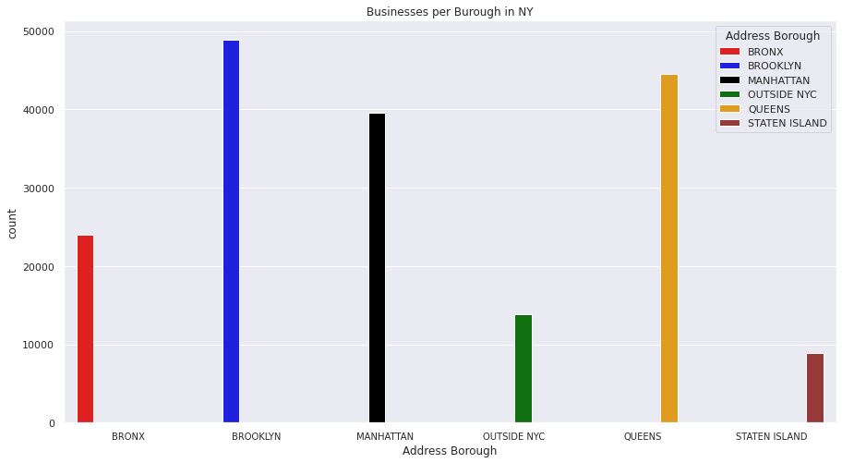

**Graph 2.2**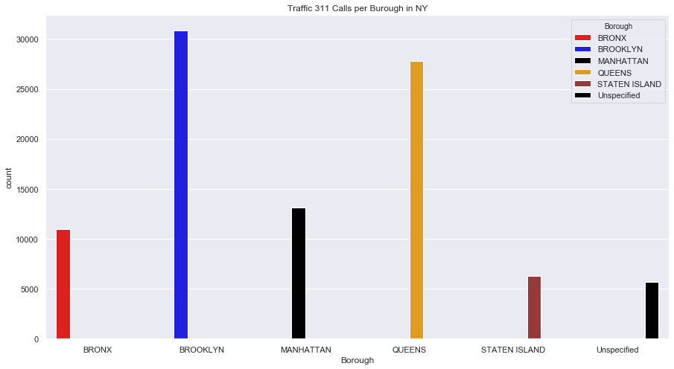

Moving on to Washington, D.C., we decided to divide the U.S. capital into its eight wards. Here we can spot the same trend that we found in New York. A larger number of businesses in a ward seems to imply a higher volume of traffic in that ward, since there are higher counts of traffic 311 calls in those areas. If we compare the two graphics below, we can see that the number of businesses and traffic calls per ward follow a similar trend.

**Graph 2.3**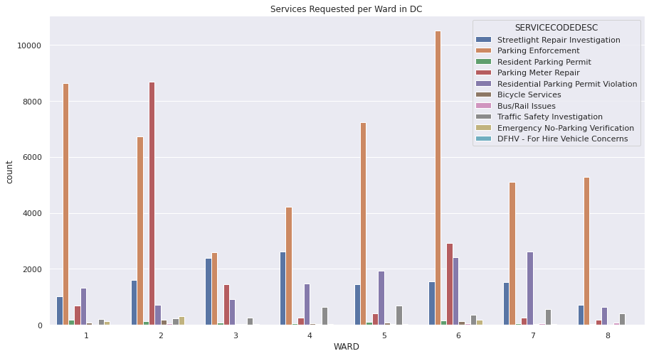

**Graph 2.4**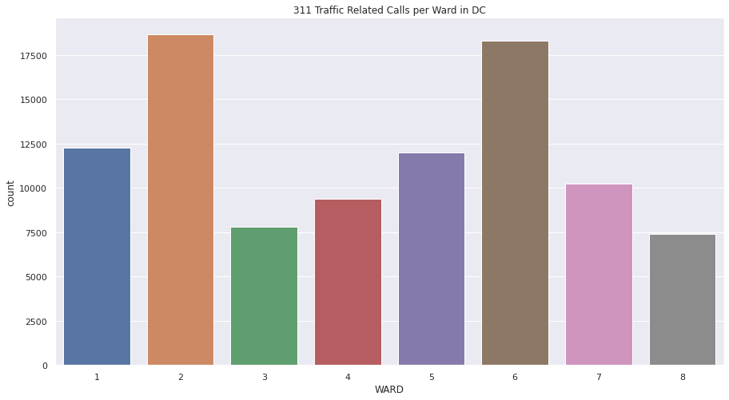

**Graph 2.5**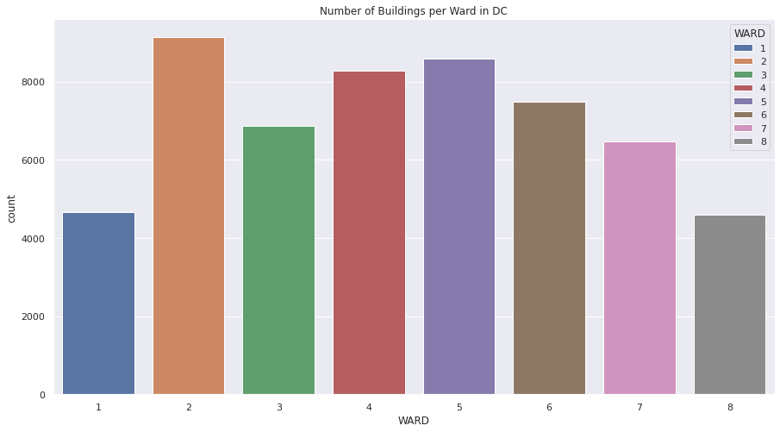

Austin, TX has many counties, but there were only two that received service requests related to traffic. Here we compare Williamson and Travis County to see if more businesses implies a higher volume of traffic using 311 calls as a metric. Sticking to the pattern present in D.C. and New York, Travis County has more businesses and more traffic 311 calls than Williamson County. The graphics below illustrate the differences between the two counties, and support the trend that we have seen in each city.

**Graph 2.6**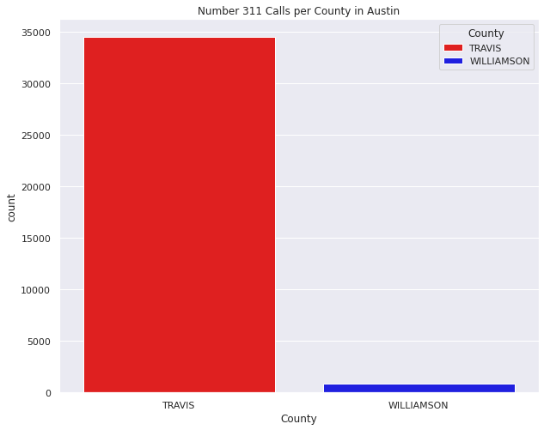

**Graph 2.7**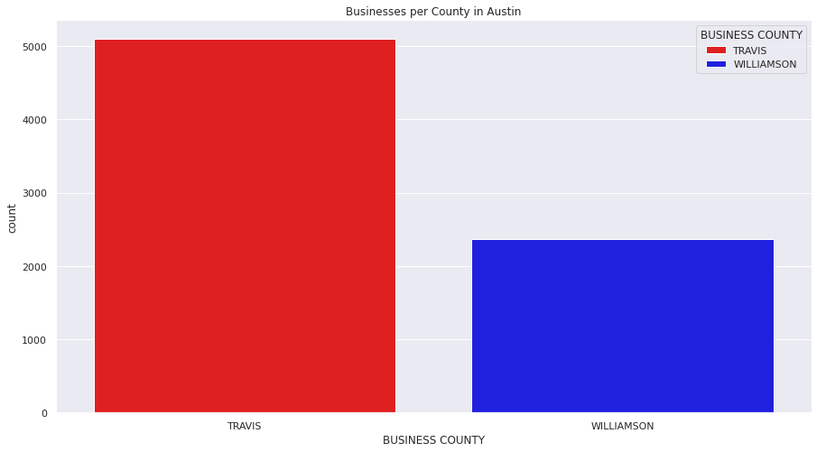

**Graph 2.8**

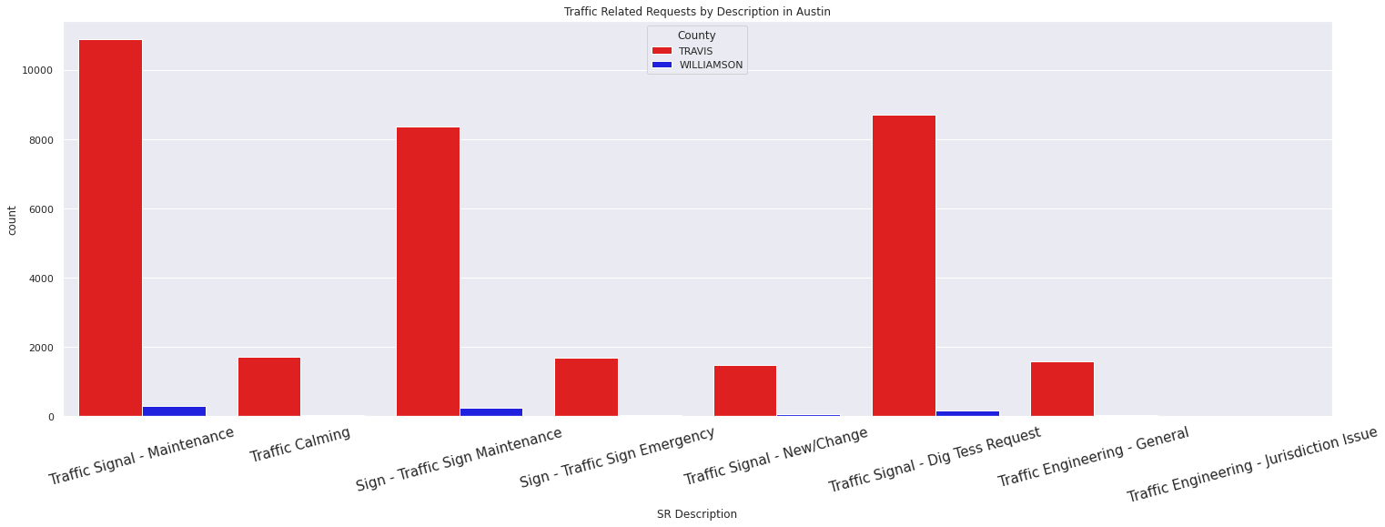

In Austin, D.C., and New York we have found a pretty correlation between the number of businesses and the number of traffic related service requests. The more businesses in an area typically implies larger volumes of traffic as measured by the number of requests.

Although we are very confident in this relationship and our findings, we need to keep a few things in mind. Traffic 311 calls are not necessarily a strong predictor of the volume of traffic. We are making the assumption that areas with a higher number of calls will have a higher number of travelers. We believe that busier areas will have a higher likelihood of needing service, and we believe that a service is more likely to be requested since there are more people.

The second assumption we are making is that the number of businesses in an area employ roughly the same number of people. Businesses vary in size and employees. Bigger businesses may attract more commuters than a collection of smaller businesses. As a result, we could find an area with less businesses and more traffic because the area with less businesses has bigger businesses which employ more people.

## **5. Recommendations**

Business and education are cornerstones of communities in the United States. Local governments have to ensure strong businesses and maintain an educated population to the best of their abilities. We want to make sure that citizens are safe and satisfied on their trips between the establishments that build a city. Traffic congestion isn’t fun or safe for city residents, yet in our analysis we find that an increase in business leads to an increase in traffic volume. Governments have to balance the need for strong businesses while managing traffic.

We suggest that governments first invest in better traffic equipment to ensure safety and avoid confusion amongst drivers. The number and concentration of requests shows that governments need to invest in better traffic equipment in areas with a lot of businesses. We encourage governments to spread businesses out more through initiatives if at all possible. We found that areas that have a high concentration of businesses tend to draw in more people. This natural attraction of the workforce in a given community drives the high levels of traffic volume that we see in our data.

Next, we found that a more educated public decreases traffic and therefore the risks associated with travel. There is also a relation between the types of majors pursued. With more majors in tech and finance or other work from home related fields the traffic congestion lowers and road safety improves. Governments are urged to continually invest in education in order to increase the number of work from home jobs and lower traffic. They can also encourage residents to pursue majors that lead to work from home jobs, which also reduces traffic. By strengthening infrastructure, education, and business in dense areas governments will see an increase in safety on the road.

## 

## 

## **6. References**

[1] College Majors statistics, from datausa.io. URLs:

New York, NY: [https://datausa.io/profile/geo/new-york-ny](https://datausa.io/profile/geo/new-york-ny#majors)

Washington, DC: [https://datausa.io/profile/geo/washington-dc](https://datausa.io/profile/geo/washington-dc#majors)

Austin, TX: [https://datausa.io/profile/geo/austin-tx](https://datausa.io/profile/geo/austin-tx#majors)

[2] Educational Achievement statistics, from USDA Economic Research Service. URL: <https://data.ers.usda.gov/reports.aspx?ID=17829>

[3] Congestion Index statistic, from United States Department of Transportation, Bureau of Transportation Statistics. URL: <https://www.bts.gov/content/annual-roadway-congestion-index>